WISDOM TEETH

Q Why do we have wisdom teeth?

A Adults can have up to 32 teeth. The wisdom teeth are the last to come through, right at the back. They usually appear when you are between 17 and 25, although sometimes they appear many years later.

Nowadays people often have jaws that are too small for all 32 teeth – 28 is often the most we have room for. So if all the other teeth are present and healthy there may not be enough space for the wisdom teeth to come through properly.

Q Do they always cause problems?

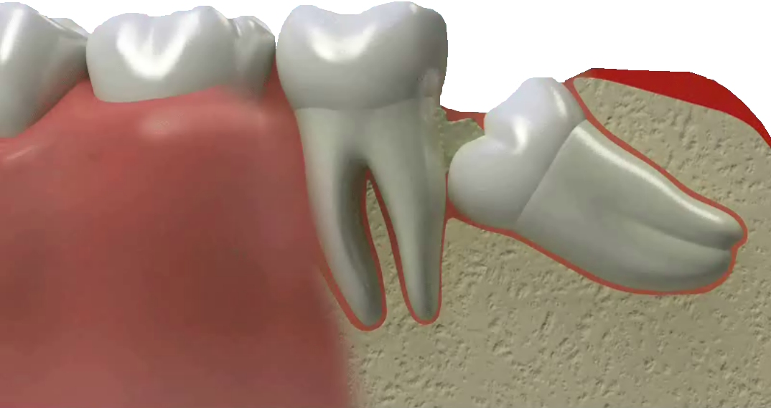
A No. If there is enough room they will usually come through into a useful position and cause no more problems than any other tooth.

Often there will be some slight discomfort as they come through, but this is only temporary and will disappear once the tooth is fully in position.

Q What is an impacted wisdom tooth?

A If there is not enough room, the wisdom tooth may try to come through, but will get stuck against the tooth in front of it. The wisdom tooth will be at an angle, and will be described by the dentist as ‘impacted’.

Q What problems should I be prepared for?

A If part of the wisdom tooth has appeared through the gum and part of it is still covered, the gum may become sore and perhaps swollen. Food particles and bacteria can collect under the gum edge, and it will be difficult to clean the area effectively.

Your dentist will tell you whether this is a temporary problem that can be dealt with by using mouthwashes and special cleaning methods (and possibly antibiotics), or whether it is better to have the tooth removed.

Q What can I do to help myself?

A If your gums are sore and swollen, use a mouthwash of medium hot water with a teaspoonful of salt. (Check that it is not too hot before using it.) Swish the salt water around the tooth, trying to get into the areas your toothbrush cannot reach. An antibacterial mouthwash such as Corsodyl can also reduce the inflammation. Pain-relieving tablets such as paracetamol or aspirin can also be useful in the short term, but see your dentist if the pain continues.

Q But if it does not help?

A If the pain does not go away or if you find it difficult to open your mouth, you should see a dentist. They will be able to see the cause of the problem, and tell you what to do. It may help to clean around the tooth very thoroughly, and the dentist may give you a prescription for an antibiotic.

Q Are x-rays needed?

A The dentist will usually take x-rays to see the position of the root, and to see whether there is room for the tooth to come through into a useful position.

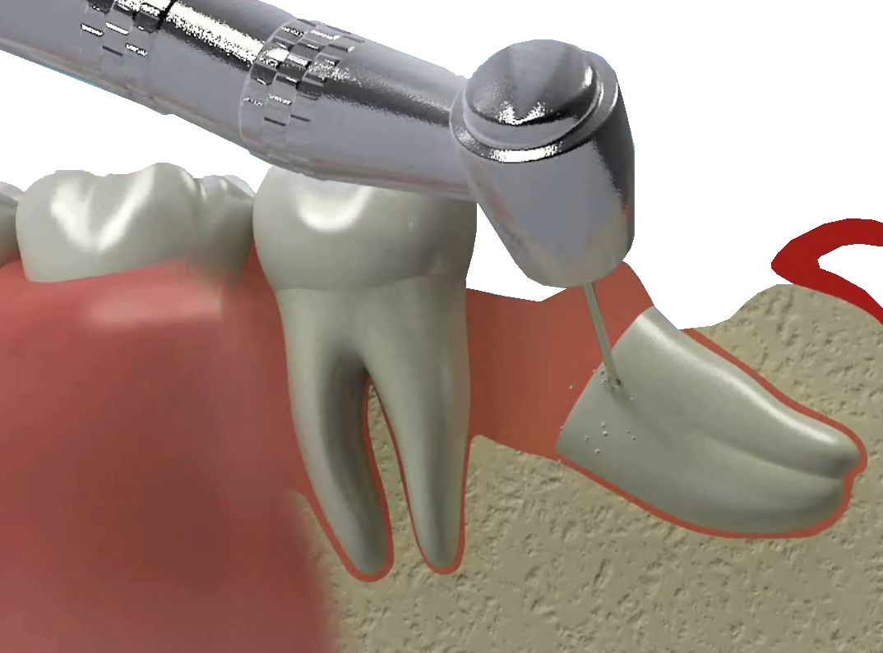
Q What are the main reasons for taking wisdom teeth out?
A
- When it is clear that the wisdom teeth will not be able to come through into a useful position because there is not enough room, and they are also causing some pain or discomfort.

- If they have only partly come through and are decayed – such teeth will often be more likely to decay as it will be difficult to clean them as thoroughly as your other teeth.

- If the wisdom tooth is causing a cleaning problem and has no real use.

- If the wisdom tooth starts to ‘over-grow’. This often happens if the lower one has already been removed or is impacted and cannot come through, and the upper one has no tooth to bite against. The upper one will come down too far, looking for a tooth to make contact with.

- If they are painful.

Q Are wisdom teeth difficult to take out?

A It all depends on the position and the shape of the roots. Your dentist will tell you how easy or difficult each tooth will be to remove after looking at the x-rays. Upper wisdom teeth are often easier to remove than lower ones, which are more likely to be impacted. Your dentist will say whether the tooth should be taken out at the dental practice, or whether you should be referred to a specialist (oral surgeon) at a hospital. Very occasionally there is a possibility of some numbness of the lip after the removal of a lower tooth – your dentist will tell you if it is possible in your case.

You will probably have either a local anaesthetic – as you would have for a filling – or sedation. You could also have a general anaesthetic (where you would be asleep), but this will usually be given only in a hospital.

Q Will it make any difference to my face or mouth?

A Taking wisdom teeth out may cause some swelling for a few days. But as soon as the area is healed, there will be no difference to your face or appearance. Your mouth will feel more comfortable and less crowded, especially if the teeth were impacted.

Q What should I expect after a wisdom tooth is taken out?

A The amount of discomfort will depend on how easy it was to take the tooth out. There is usually some swelling and discomfort for a few days afterwards, and it is important to follow any advice you get about mouthwashes and so on, to help with the healing. Some people also find homeopathic remedies help to reduce discomfort. Usual painkillers such as paracetamol, aspirin or ibuprofen will usually deal with any pain. It is best to stay fairly quiet and relaxed for 24 hours afterwards to make sue there are no bleeding problems. There may be some stitches to help the gum heal over. Your dentist will probably want to see you again about a week later to check on the healing, and to remove any stitches.

Q What does it cost?

A At hospital all treatment is free. At the dentist it is free if you are under 18, or exempt from NHS charges. Otherwise the cost depends on what is involved. It is important that you discuss costs and payment methods with your dentist before starting treatment.

